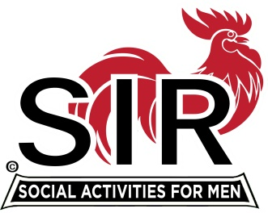
Las Trampas Branch 116
Luncheon Meeting Agenda
March 21, 2022, 10:30 AM

10:30 Check-in
Greeters at the door – Paul Ramacciotti, Alan Pope
Vaccination Check table – Kevin Donahue
Treasurer Table – Alan Fitzgerald, Al Satake, David Ferm
Name Tags Table – Mike Schneider
Raffle Table – Ben Bryce

11:25 Five Minute Call
11:30 Call to order; Welcome back to all – Big SIR
Pledge of Allegiance – Mac McLoughlin
Chaplain – Terry Sherman
Sunshine Report – Matt Arena

11:40 Story Teller – Mac McLoughlin
11:45 Introduce and Welcome New Members [since covid] & guests – Big SIR/Sponsors
Recognize all who worked hard to keep branch viable during last 25 months and any Branch award holders

11:45 Salad Served
12:00 Lunch
12:10 Activity Committee Announcements Alex Lutkus
12:20 Introduce Speaker, Carolyn Jackson – Little SIR Roger Craig
13:05 Speaker Thank You – Little SIR Roger Craig
13:10 Raffle Drawing – Ben Bryce
Birthday Drawing and – Little SIR Roger Craig
13:20 Sing Happy Birthday – Music – Dave Williams, Paul King
Sing God Bless America - Dave Williams, Paul King

13:25 Closing Remarks – Big SIR
13:30 Adjourn; Next Meeting, April 18th
************************************************
New Members – joining during pandemic – Members highlighted in green are attending today’s luncheon.
Rob | Lemmo
Jim | Hemmenway
David | Williams
Bill | Foulds
Lyle | Buckert
Bob | Romero
Dick | Frankel
Dave | Havlik
Bruce | Kessler
Whitey | Davis
Jim | Avila
Rich | Yamanaka
Jack | Minicucci
Ken | Nigro
Don | Nix
Nick | Nicholas
Doug | Janes
Dave | Williams

Guests for March 21, 2022:
Cully Anderson
Frank Canova
Cameron Kauffman
Carolyn Jackson
David LaDue
Dan Lawrence

